**Practical no. 9**

**FS19CO042**

**Aim:** Configure static and dynamic IP addresses

**Tool used:** Cisco Packet tracer student software.

**Required components:** Wireless router, PC, Laptop, Mobile, Tablet

**Theory and steps:**

* **IP address**  
  IP address is an address of device’s network hardware. It is used to identify devices to send/receive data.   
  Every device connected to internet have a unique IP address   
  There are two versions of IP addresses:   
  IPv4 (Has space of over 4 billion IP addresses)  
  IPv6 (Has space of upto trillions of IP addresses)  
    
  IP addresses can be classified as   
  + **Private IP address**  
    It is the IP address of device connected to home or business network. It is used to uniquely identify devices only in LAN and cannot be accessed from devices outside LAN.  
    For example, 192.168.1.2
  + **Public IP address**

It is the main IP address that uniquely identifies a device on internet and facilitates transfer from/to from network outside LAN

* **Allocation of IP address**  
    
  All private and public IP addresses can either be **static (same for specific device all the time)** or **dynamic (changes with time).**  
  IP addresses can be manually configured and fixed for a particular network device, These don’t change automatically. These are static IP addresses.  
  Dynamic IP address is configured automatically by router when a device is connected to router/hub/switch. It may or may not change every time reconnected. It is managed by Dynamic Host Configuration Protocol (DHCP). DHCP is the internet router in LAN, whereas ISP’s switches/hub, etc. is DHCP for external internet.

**Allocating dynamic IP addresses:**

IP addresses are allocated dynamically by default, hence there is no manual configuration required.  
To verify that device is using DHCP i.e. dynamically allocated IP, following steps can be performed:

* Verifying dynamic IP addresses on mobile phones
  1. Open **Settings** application on device and make sure that WiFi is turned
  2. Graphical user interface, application

     Description automatically generatedClick on WiFi section
  3. Graphical user interface, text, application, email

     Description automatically generatedConnect to preferred wireless router’s SSID and click on SSID once connected.
  4. Graphical user interface, application, email

     Description automatically generatedIn the WiFi details window, search for **IP settings** and verify that it is set to DHCP
  5. A picture containing graphical user interface

     Description automatically generatedIf **IP settings**  is set as DHCP, click on **IP settings**  and select **DHCP.** Go back to WiFi list window,  
     Device would reconnect to router if IP settings mode is changed and device will be allocated dynamic IP address automatically. now.
* Verifying dynamic IP addresses on desktop/laptops

1. 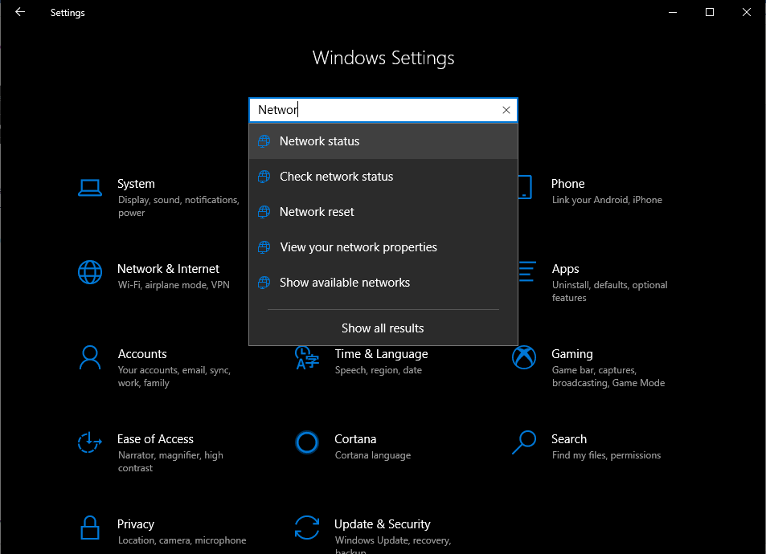Open Settings from Start menu and search for **Network**, Click on Network status
2. 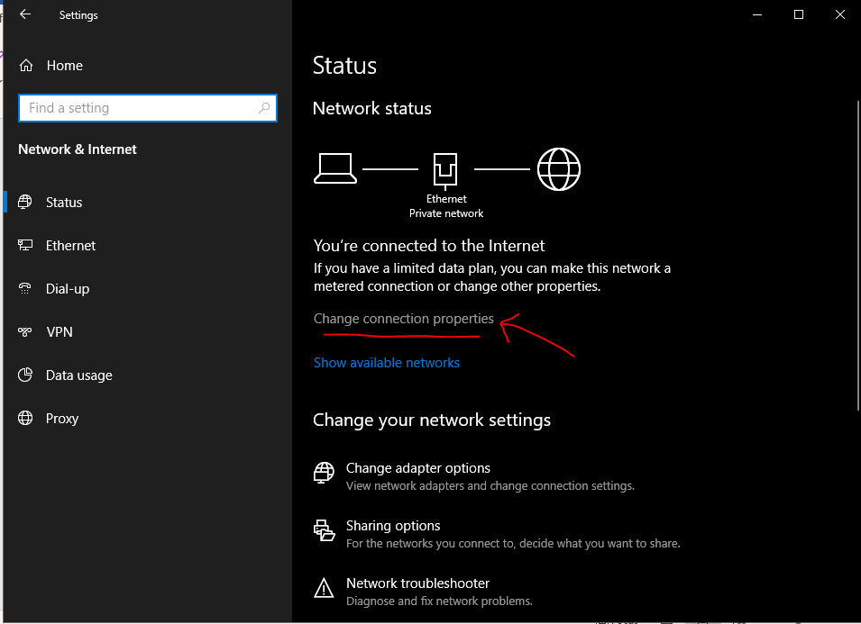In Network status window, click on **Change connection properties**
3. 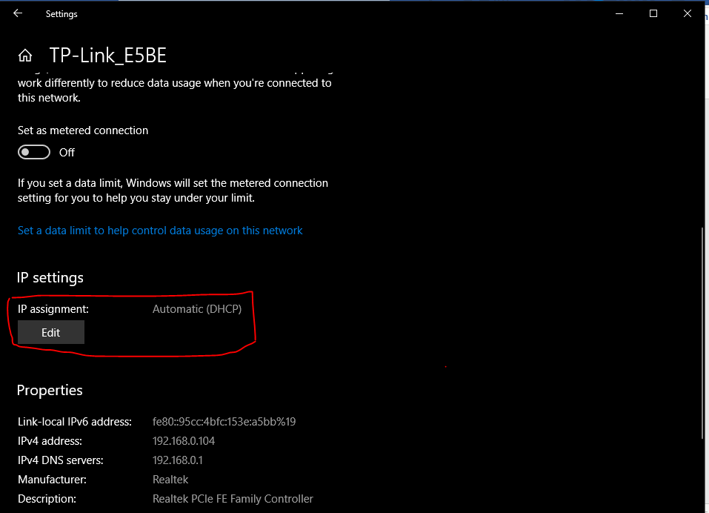In the network Connection window, look for **IP settings** and check if **IP assignment** property is set to DHCP
4. 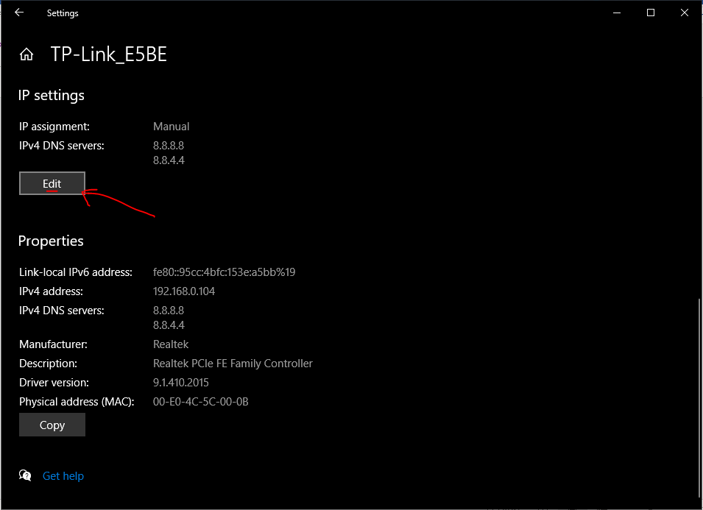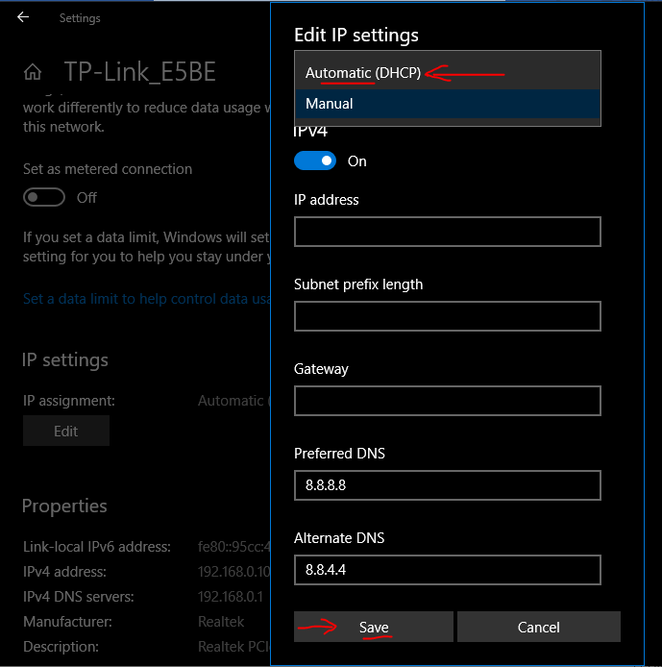If **IP assignment** is set to Manual, click on Edit, select DHCP and click save.  
   Provide administrator permissions if asked.  
     
   **Allocating static IP addresses:**

To set IP as static, perform following steps:

* Setting static IP addresses on mobile phones
  1. Open **Settings** application on device and make sure that WiFi is turned on.
  2. Click on WiFi section and open connected SSID as done in dynamic IP verification above.
  3. Graphical user interface, text, application, email

     Description automatically generatedConnect to preferred wireless router’s SSID and click on SSID once connected.
  4. **Graphical user interface, application

     Description automatically generated**In the WiFi details window, look for **IP settings**, click on it and select static mode.
  5. **Graphical user interface, application, Teams

     Description automatically generated**If the **IP settings** is set to DHCP (it is selected by default), click on it and toggle it to **Static.**
  6. **Graphical user interface, text, application, email

     Description automatically generated**Edit the IP Address and choose a concrete IP to use for device.
* **Setting static IP addresses on desktops/laptops**

Follow these steps:

1. Open Settings from Start menu and search for **Network**, Click on Network status
2. In Network status window, click on **Change connection properties**

In the network Connection window, look for **IP settings** and check if **IP assignment** property is set to DHCP

1. In the network Connection window, look for **IP settings**. It is set to DHCP by default.  
   Toggle it to **Manual or Static** and turn on IPv4 and/or IPv6 as desired.
2. 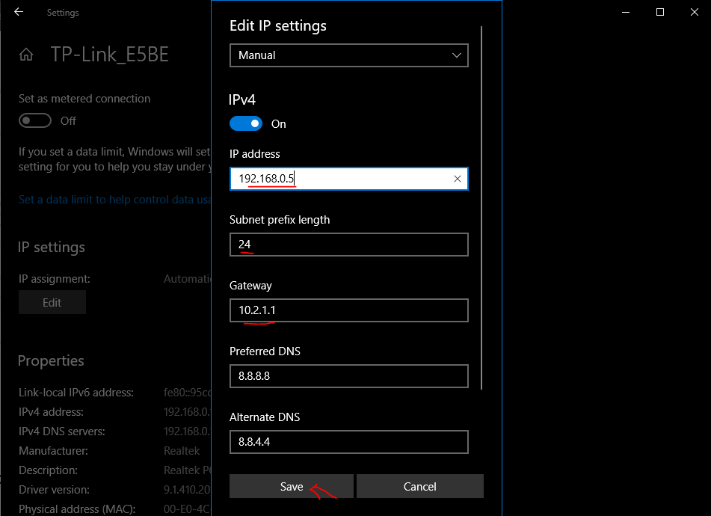Enter desired IP in IP address field.  
   Set the **Subnet prefix length** (subnet mask). If your subnet mask is **255.255.255.0**, then the subnet prefix length in bits is **24**.  
   Set default gateway address. Lastly, you can edit Option fields: (Preferred DNS and Alternate DNS) if you want. Click on save and provide administrator permissions if prompted.
3. 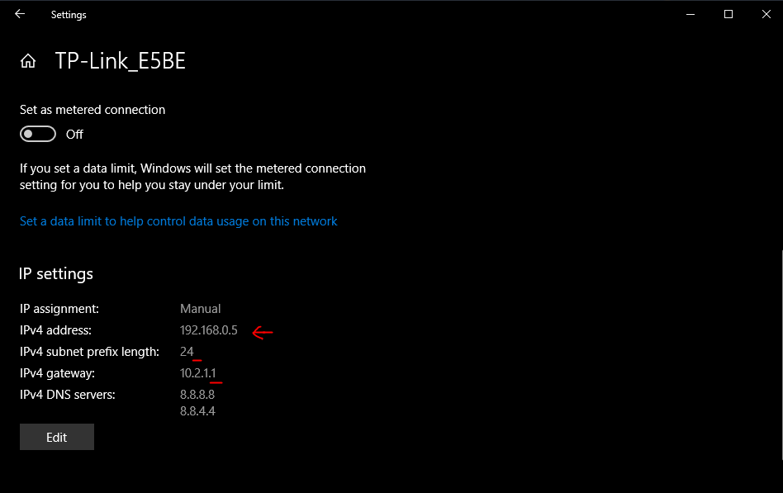 Changes can be seen after saving in IP settings section.  
     
     
    **Conclusion: In this experiment, we configured dynamic and static IP addresses in devices.**